**Template Specific Features**

1. **Looking for Inspirations from Europol Cybercrime portals**
2. Ireland (<https://www.garda.ie/en/>)

We can highlight an anonymous Reporting section for scam centers on front page(2nd Tab on Nav Bar)

Can have Searchbar for Cybercrime police stations nearby (4th Tab on Nav Bar)

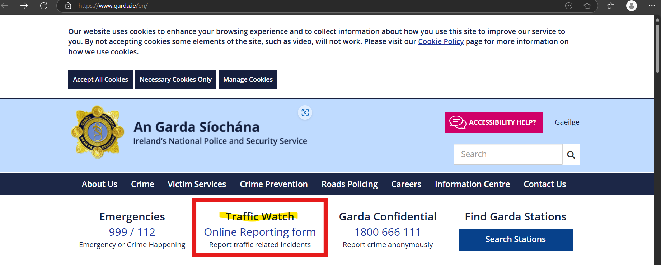

1. Spain (<https://www.policia.es/_es/denuncias.php#>)

We can have descriptive FAQs and a chatbot support for follow ups

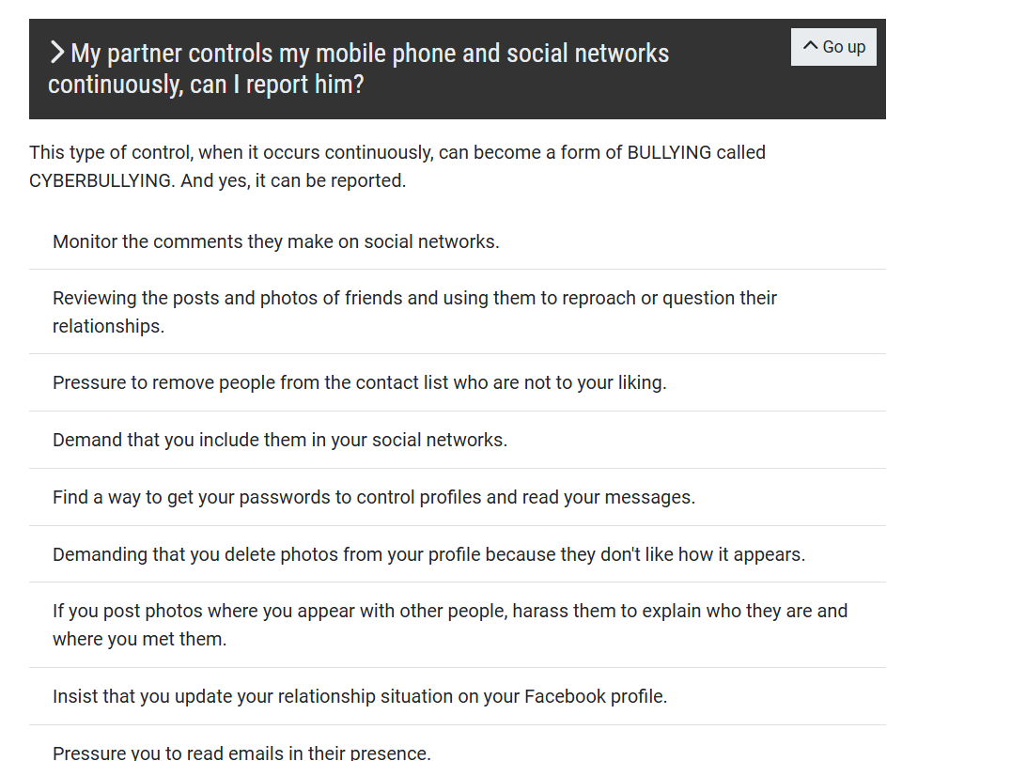

1. Italy (<https://www.commissariatodips.it/>)

We can have suggestive descriptive posts from I4C Socials Like Cyberdost, etc

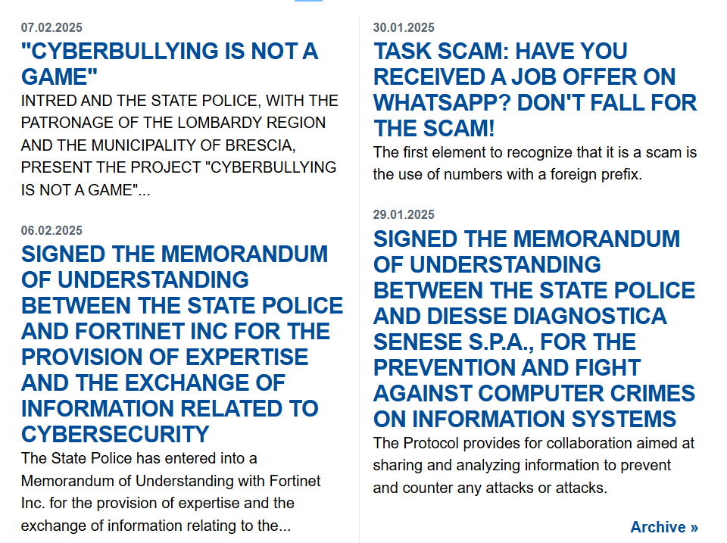

1. Denmark () <https://politi.dk/>

Very Modern Design

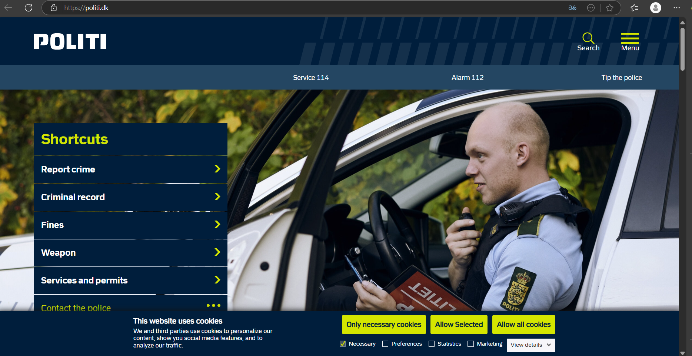

1. United Kingdom (<https://www.actionfraud.police.uk/>)

Virtual Advisor with Modern Design

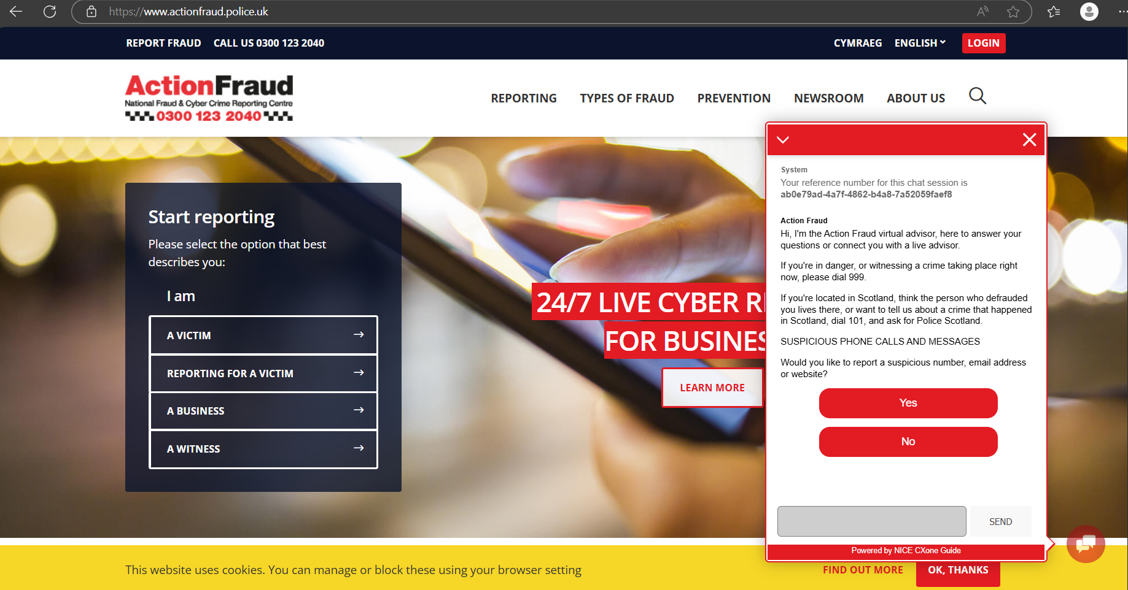

1. Finland (<https://poliisi.fi/en/report-a-crime>)

Didn’t liked the website Design but feedback system seems good

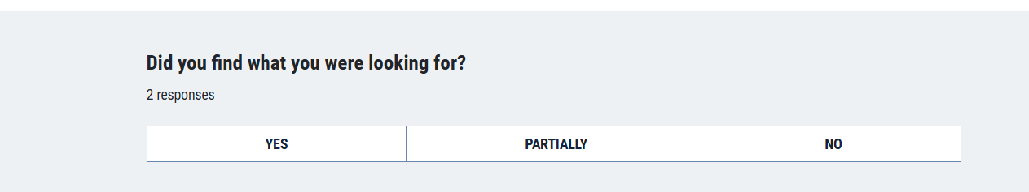

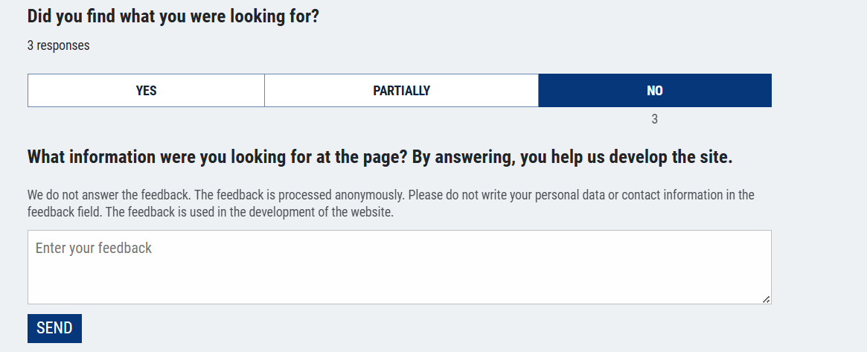

1. France (<https://poliisi.fi/en/report-a-crime>)

Very Simple Design (Simple Color palette)

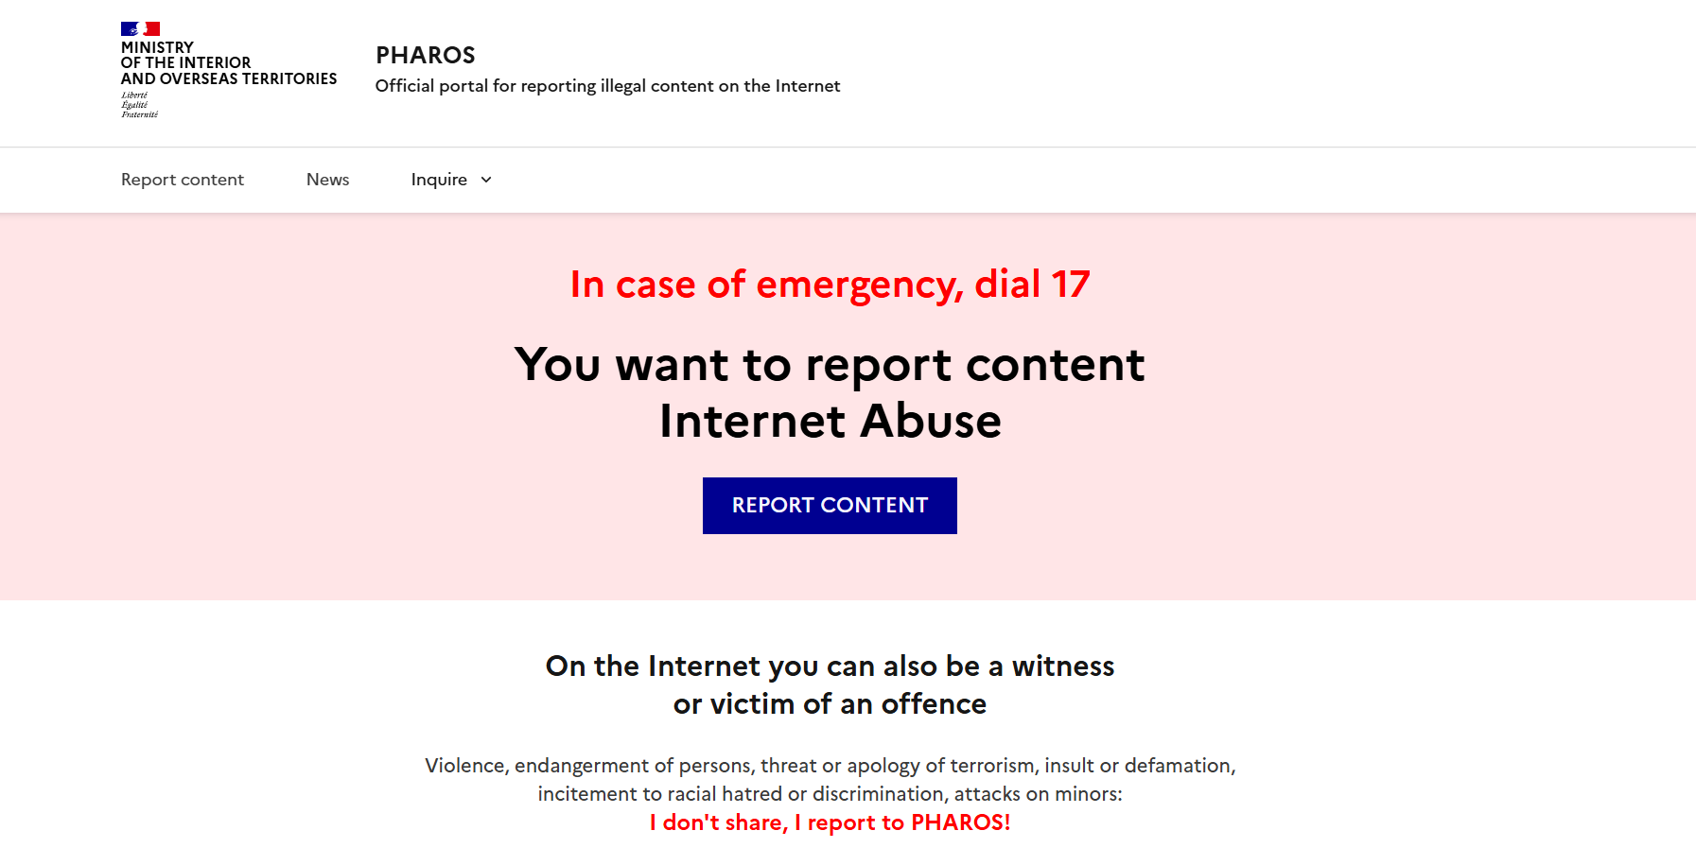

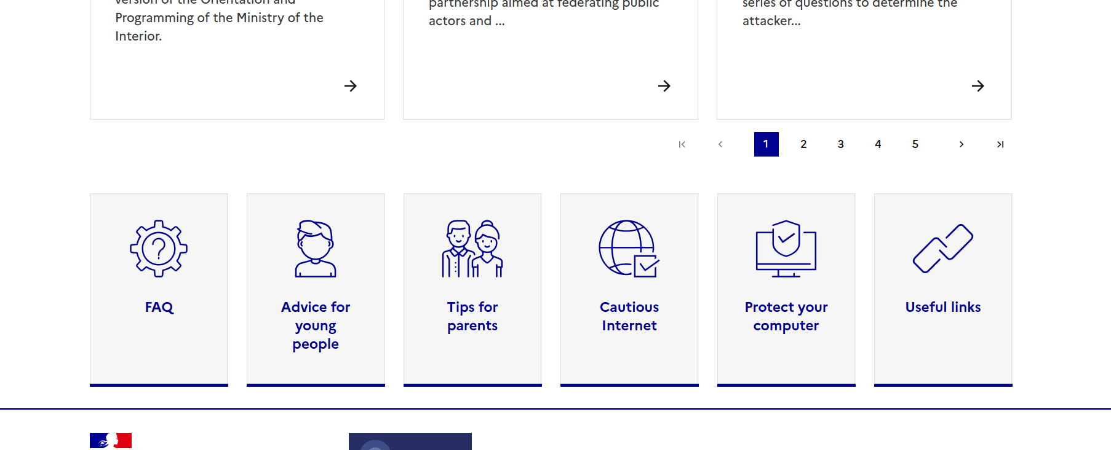

**A1. Templates that can be used**

1. Ireland - <https://www.garda.ie/en/>
2. Spain - <https://www.policia.es/_es/denuncias.php#>
3. Italy - <https://www.commissariatodips.it/>
4. Denmark - <https://politi.dk/>
5. United Kingdom - <https://www.actionfraud.police.uk/>
6. Finland - <https://poliisi.fi/en/report-a-crime>
7. France - <https://www.internet-signalement.gouv.fr/PharosS1/>